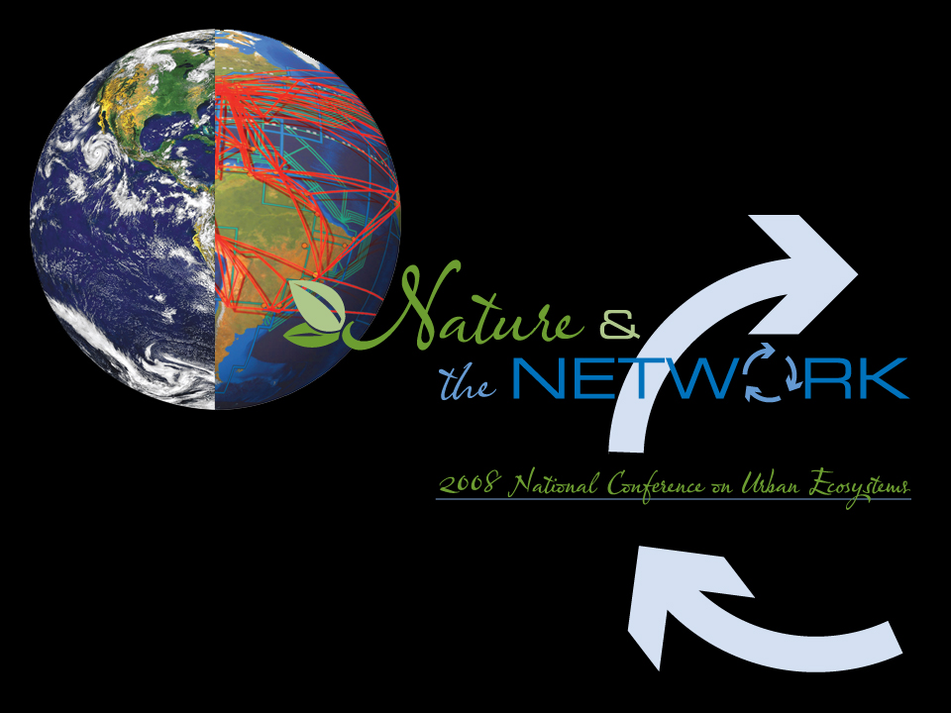
Orlando, Florida – May 28 – 30, 2008

A Selection of Presentation Summaries

