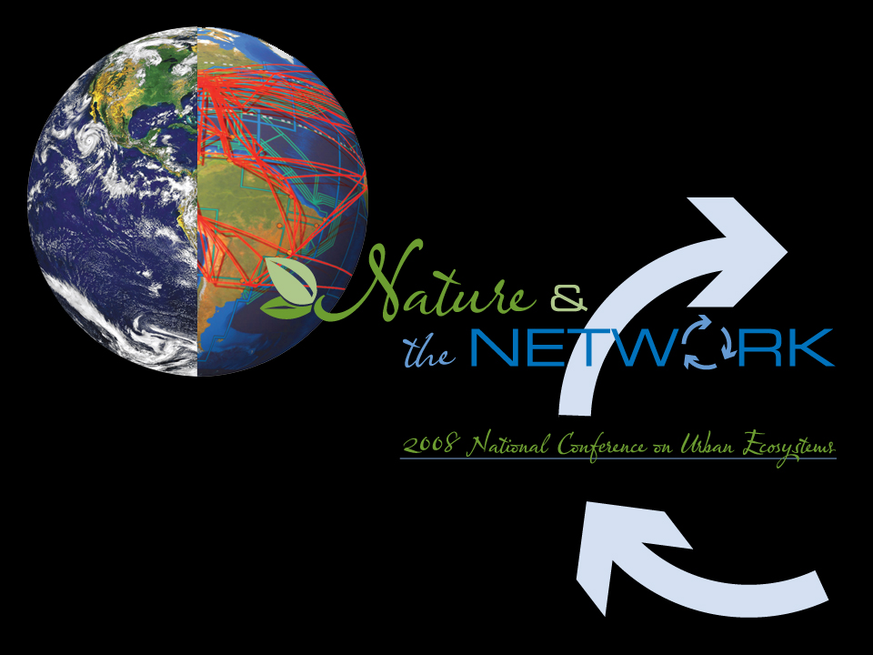
May 28 – 30, 2008 | Orlando, Florida

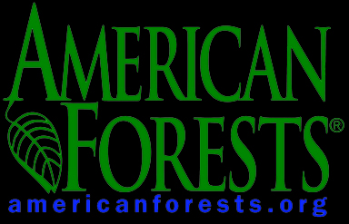
Selected Presentation Summaries

Organized by American Forests

Supported by the US Forest Service and
The Davey Tree Expert Company

