Selected Presentation Summaries

Nature and the Network
The 2008 National Conference on Urban Ecosystems

Organized by: American Forests

Supported by: US Forest Service
The Davey Tree Expert Company

© 2008 American Forests

American Forests
P.O. Box 2000
Washington, DC 20013

The use of trade, firm, or supply names in this publication is for the information and convenience of the reader. Such use does not constitute an endorsement or approval of any product or service to exclusion of others.

This publication may not be reproduced without permission of American Forests.
Table of Contents

Sustainable Tree Ordinances 3

Buck Abbey, ASLA

Robert Reich School of Landscape Architecture

Louisiana State University

Decision Support Tools for Counties, Communities and Planners 9

James Fox, National Environmental Modeling and Analysis Center

University of North Carolina Asheville

Transportation Investments as Investments in the Environment 13

Emil Frankel, Independent Consultant

Director of Transportation Policy, Bipartisan Policy Center and

former Assistant Secretary for Transportation of US DOT

Using Forest Canopy Cover Mapping to Plan the Community Network 17

Jennifer Gulick, Davey Resource Group, Walton, Kentucky

Framing the Issues with Green Infrastructure 20

Cheryl Kollin, Vice President, Urban Ecosystem Center

American Forests, Washington DC

Sustainable Tree Ordinances

Buck Abbey, ASLA

Robert Reich School of Landscape Architecture

Louisiana State University

Abstract: Tree Ordinances are about to enter a new era. There are trends being initiated to make these urban forestry tools based in part on sustainable practices.

Green Cities

Frederick Law Olmsted (1822-1903), writer, urban visionary, park planner and founder of landscape architecture realized early in his career that for a city to be sustainable, it must have adequate open spaces, clean air and a wholesome environment flanked by trees, meadows, streams and opportunities for recreation and social gathering.

Olmsted was one of the first to recognize that if cities are to be sustainable, they must be designed using native plant materials and natural processes that will stand up to time and the temptation of age to weather and fail. He relied upon trees and the urban forests in his many parks and principal urban spaces of cities across the nation to provide elements of nature that are truly sustainable. Nature in the city does work and provides ecosystem services. This is the reason that Central Park (1858) in New York has survived most buildings and social institutions of its age. The landscape will sustain itself.

Sustainability in the Urban Forest

New Yorkers realize the future of this great American city is based on making the city livable while meeting the challenges posed by an environment under stress due to growth and development. To meet these challenges New York City has adopted a sustainability plan, dubbed Planyc. Mayor Michael Bloomberg and the City Planning Department staff have prepared this plan to green the city. Urban forestry plays a significant role in this plan.

Some one hundred twenty-seven (127) new initiatives are underway including several that will produce a sustainable urban forest. These initiatives include greening parking lot, incentives for green roofs, protecting wetlands, and using storm water BMP’s to clean urban runoff.

One of the first initiatives to be implemented is New York’s recently adopted, and first ever, landscape code. The landscape code provides standards for parking lot design, street yard garden design, enhanced open space standards, buffer yards and standards for on-site storm water management. Parking lots will be used to filter water within bioswales.

Other sustainable practices in this city of eight (8) million citizens include greening the cityscape, adding additional open space, public parks, playground, multipurpose fields, ‘blueways’, ‘greenstreets’, and public plazas so that no resident lives more than ten (10) minutes from public forested area. Part of this innovative city plan is to increase tree plantings to 5.2 million existing trees in the city on both private land, within parks and along public streets. All parking lots in the city will be planted with trees as well to improve air quality. The Planyc also envisions that all city streets especially in neighborhoods will be planted to achieve 100% ‘stocking’ by the year 2030. Over a million trees will be planted at the rate of twenty thousand five hundred (20,500) tree per year at an annual cost of seventeen (17) million dollars.

The Sustainable City

Cities must not only have Sustainability Plan as we have seen in New York City but must adopt community policy by ordinance as well. In this regard, there may be no better city to examine than Santa Monica, California, a city of 84,000 citizens to see how urban forestry is central to a sustainable city.

Santa Monica's community forest is comprised of 33,500 trees located in public areas throughout the community. Two hundred different species are present with the most prevalent species being Washingtonia sp and Ficus sp. Trees in this community include broadleaf evergreens, broadleaf deciduous, conifers and palms. The latter contributes most significantly to the urban forest canopy in this 8.3 square mile community. The urban forest is measurable so in this community there is one public tree for every two and one half citizens. Thousands of other trees grow on privately owned land in back yards and on commercial properties. Forest management in Santa Monica includes tree planting, inspection, trimming and removal. The existing tree ordinance and technical tree manual crafted by the city provides information to developers and builders for tree protection during construction on private property.

This community forest--providing the benefits of shade in the summer, sanctuary for urban wildlife, reductions in air and water pollution and increased property values is central to achieving the objectives of the Sustainable City Program.

San Monica touts itself as ‘the sustainable city’ and has been working to make the city impact neutral for several decades. This community has set a variety of policies that will lead the city to a sustainable future. Among other initiatives, this community has policy that implements sustainable urban forestry.

Policy and administrative procedures for urban forestry practices are found under the topics ‘resource conservation’, ‘open space’ and ‘land use’. With each sustainable topic, the city has established goals, indicators and targets for performance. The have developed a sustainability plan and monitor success on a periodic basis.

Sustainability Metrics

Urban Forestry sustainability metrics, are built around several factors that include green building and tree protection, accessibility to open space and parks, trees, storm water management, irrigation control and use of regionally appropriate vegetation. The sustainable urban forestry goal in Santa Monica is to develop and maintain a sufficient open space system so that it is diverse in uses and opportunities and includes natural function/wildlife habitat as well as passive and active recreation with an equitable distribution of parks, trees and pathways throughout the community. The key to having a successful urban forest is having ample public open space supplemented by private wooded lands. Tax incentives could be used to allow land along streams, on steep slopes and in other sensitive environmental areas to remain undeveloped.

Santa Monica measures the percent of tree canopy coverage by neighborhood and by land use. This inventory is essential in understanding the composition and management needs of the urban forest. Public officials also measure the percent of newly planted and total number of trees that meet defined sustainability criteria. The target for tree canopy is to have an upward trend in the percentage of tree cover throughout the community and to reach a minimum goal of 18% canopy coverage within residential areas and 25% canopy coverage within commercial areas of the city.

The community landscape code, Part 9.04.10.04 (qcode.us/codes), is a second measure of urban forestry sustainability and is an important tool for creating a sustainable landscape. All areas of a development site not covered by buildings, driveways and sidewalks must be landscaped. This code sets design standards for drought tolerant landscaping and the use of appropriate plants based upon adaptability of the climate and topographical conditions of the building site.

A third measure of urban forestry sustainability in this community is water. This includes storm water management, water harvesting and irrigation control. Water in a community is directly tied to urban forestry in obvious ways. Pure water and water quality and its sustainability are immediately recognized as important by everyone. However, pure oxygen, (O₂) produced by the urban forest is not. To make the case for sustainable tree ordinances, water needs and design practices need to be brought into most community tree ordinances.
Water harvesting is the collection, storage and reuse of a natural resource. Communities that need all of the water they can harvest will capture water on site by establishing a ‘capture rate’ based upon a percentage of the water that falls on a development site. This percentage in the wet east may be in the area of 30% of rainfall or in the dry west up to 100%. Rainfall may be harvested from roof-tops and parking surfaces easily. Stored in an irrigation cistern, filtered and pumped, this harvested water can be recycled through an irrigation system to nourish the urban forest or landscape plantings. Even grey water from non-septic household activities, bathing, hand washing, clothes cleaning, and dishwashing can be captured and redirected into planting beds.

Santa Monica’s Urban Runoff Ordinance, Sec. 7.10.060, (qcode.us/codes) complements the community landscape code in regards to water. Rainfall must be carefully managed in a community with seventeen (17.2) inches of rainfall annually and water needs of thirteen (13) million gallons a day.

Rain water and spill water eventually finds its way to SMURRF the city’s storm water urban runoff recycling facility that cleans all runoff before it is released into Santa Monica Bay. The recycling facility provides a sustainable alternative used water supply for the city as well.

Santa Monica’s Sustainable City Plan provides a roadmap to ensure that the city meets it current environmental, economic and social needs without impacting the ability of future generations to do the same.

Tree Ordinance Sustainability Issues

Traditional tree ordinances written prior to the year 2000 were written for several basic purposes. These include ordinances to manage public trees, provide for street tree plantings, successful tree planting & maintenance, tree removal restrictions, landscaping and to organize community forestry programs. Occasionally a tree ordinance was written for some local special purpose such as viewshed protection, designating landmark trees, or to initiate an annual Arbor Day programs. Others might be written to regulate licensing and arboricultural services.

Few tree ordinances have not been written to promote urban forest sustainability but this must change. The seeds of this program have been sown in places like New York City, Atlanta, Charleston, San Antonio, Orlando, and Chicago, as well as Volusia County, Florida and Gwinnett County, Georgia. Seattle’s Green Factor is a prime example. Irvine California’s Green Building Program is another. Homestead, Florida, Davis, California and Chapel Hill, North Carolina all have sustainability metrics to offer to tree ordinances.

Some of these newer ordinances can be casually referred to as ‘super tree laws’ due to the fact that the ordinances contain tree standards, landscape design requirements and tree or habitat preservation standards. Emphasis on the latter brings the question of sustainability to the front of this discussion.

Writers have written about sustainability strategies particularly in regards to parking lots that offer opportunities to do environmental work in the city. For some time now visionary communities such as Collier County, Florida, Raleigh, Durham and Chapel Hill in North Carolina, Mandeville and Covington, Louisiana in and Southlake, Denton and Conroe, Texas understand that the urban forest and green infrastructure of a community is indeed one of the sustainable elements of a green community. Forsythe, Gwinnett and Fulton County Georgia also understand this and their tree canopy protection clauses are reflective of sustainability.

San Antonio, Texas recently amended their zoning code and in the statement of purpose mentions eight (8) sustainable practices that are expected as a result of compliance with the tree ordinance. They mention for instance tree preservation, water conservation, air cleansing, heat island reduction, native vegetation protection and drought tolerant design.

Toward Sustainable Tree Ordinances

Olmsted recognized urban forest sustainability in the 1850’s. He noted how the London parks seemed to be the ‘lungs of London.’ New York City, Santa Monica and Albuquerque among other American cities are beginning to recognize the importance of sustainability. It is time that American tree ordinances respond to the concept of sustainability. Tree ordinances can be easily rewritten to shed a green light on the importance of the urban forest as one of the most sustainable assets of an urban community.

With the development of sophisticated forestry departments, computerized tree analysis programs and advances in urban forestry research a new era of municipal tree law is on the horizon. This new era of super tree laws beckons sustainability thinking to further preserve urban forests. Sustainability based tree ordinances will preserve all of the important environmental services that a well-treed town can provide to its citizens.

It is time that all communities realize that tree ordinances, landscape codes and land development regulations, must be modernized to include sustainability criteria.

Appendix A
Sustainable Components of Urban Forestry

I. Guiding Principles of Sustainability
- Management of the Urban Forest - planning, design, maintenance, financing
- Habitat preservation-wetlands, groves, forests, transition meadows, steep slopes, wildlife corridors, etc.
- Tree Protection During Construction - three inches for one inch replacement
- Minimum Area of Site Permeability -
- Native Materials and Ecological Conformity-native plants, exotic plants and lawn grass minimization.
- Water Management – storm water control, water conservation, water harvesting, irrigation design and control.

II. Urban Forest Sustainability Tools (ordinance articles)
- Minimum Canopy Standards
- Tree Preservation, Preserved Groves and Forest Remnants
- Screening, Buffering and Green Connectivity to Parks & Open Space
- Green Parking
- Appropriate Plant Materials
- Locally Produced Construction Materials
- Nutrient Cycling
- Photosynthesis and the Carbon Sink
- Soil Structure
- Solar Energy Orientation
- Urban Heat Island Effect
- Water Balance
- Storm Water BMP’s
- Wetlands
- Windbreaks
- Steep Slope Protection
- Human Health And Well Being

III. Monitoring and Assessing Sustainability
- Community Sustainability Plan
- Sustainability Director & Staff
- Inventory; Mapping; Monitoring; Arboricultural Management.
- Setting Sustainability Principles, Goals, and Measurable Results
- Progress Reports-indicators, activity, milestones, targets report to the citizens

Biography

D.G. ‘Buck’ Abbey, ASLA is Associate Professor in the Robert Reich School of Landscape Architecture at Louisiana State University in Baton Rouge, Louisiana. Abbey is the recipient of the 2008 Frederick Law Olmsted Award from the Arbor Day Foundation.

Decision Support Tools for Counties, Communities and Planners

James Fox, National Environmental Modeling and Analysis Center

University of North Carolina Asheville

Abstract: Decisions on land use and forest issues are made at a county scale. Tools must allow local users to access data at a proper scale and in an understandable format.

Our communities are faced with multiple challenges at the current time due to new realities – rising energy prices; population growth and related land use issues; and climate change and related water use issues. This results in competitive land use issues with new views on affordable and sustainable housing. Local decision makers, such as county commissioners and city councilors, are asking questions like: What is the sustainable level of development for our area? Are there limitations on safe drinking water? How are we going to handle the large projected population growth in our area over the next 20 years? Considering these factors, what role do forests play in our decision making process?

These are topics that we are all interested in, but we find it difficult to discuss without the proper tools. We are finding that group decision making is enhanced by using a Decision Theater. The Decision Theater has three main components: Process, Products and Portal.

The Decision Theater process is supported by several factors: 1) All relevant data is accurate, current and available to the group. 2) Visualizations are created to enable group comprehension of the data and scientific principles and see how it applies to their specific area. 3) Narrative and story telling segments are created to add meaning to the visuals, and finally, 4) a Decision Support system is available to allow the group to collectively increase shared knowledge and reduce uncertainty.

Data

Data must be accurate, current, and available to the group in a useful and useable format. In addition, the data must be locally relevant. This often means scaling or clipping national or regional GIS data sets to a smaller regional or county scale. Understanding of scale is critical in these types of tools. National data sets from the USDA US Forest Service, USGS or NOAA’s National Climatic Data Center often are very interesting to view, but hard for an individual to relate to on a local scale.

This process of providing data on an appropriate scale can be challenging with limited resources. Creating an initial data set is the first challenge – keeping it current is the second. Data sets that show evolving land use change or climate change scenarios tied to drought, only hold continuing value if they are maintained and updated. One way to meet this challenge is to utilize “middleware”. Middleware is a means of automatically querying master data sets to insure that when the original data set is updated; all subsets are updated as well.

Visualizations

GIS data (and associated maps) is critical to understanding the relationship between the natural system and the manmade. Unfortunately, many users do not understand a basic map. However, put that same information into a 3D model, and people can recognize landmarks, find their own house, etc. and grasp the complex topics being presented. This allows for a reduction of uncertainty and an increase in shared knowledge. New technologies and techniques are allowing us to create new visuals that can be tied directly to GIS data. This allows for dynamic and rapid delivery of ever changing data in a format that is more accessible and easier to understand. Visualizations in the form of 3D panoramas, with different data overlaid on the same background view, allow users to understand the relationships between different data sets and competing priorities.

Story Telling

No matter how good the visuals are, the picture can only “tell a thousand words” if put into the right context and given meaning by a narrative. The story telling must also fit specific audience needs and related decisions. Some story telling can be done for education and outreach or related purposes. This type of narrative is easier to handle, because communication is one way and linear.

Story telling in a conversational mode to support decision making is more difficult. When trying to solve complex problems, the shared understanding only comes when all members of a team or diverse audience are allowed to participate. This “shared storytelling” becomes an iterative process that is an important way to reach group consensus.

We have also found that reducing uncertainty comes by combining images in different formats, because different people learn in different ways. Some people are very well versed on issues and need just points of connection. Other people need greater support with educational materials before they feel comfortable contributing. Therefore, the story telling tools that are modular can fit a wider range of audience needs.

In addition, our society has become a much more “video driven” society. They are much more willing to access data and participate in decision making teams if they can use technologies that they are comfortable with. To address this issue, we are creating movies and other 3D tools to help tell the story.

One exciting new tool is the GeoDome. The GeoDome is an immersive 3D theater where groups of people can interact with 3D data. The dome itself is portable because it uses the same inflatable space technology that children’s “bouncy castles” employ. The projection equipment is a high-end laptop PC connected to a high resolution projector with a fish-eye lens. The GeoDome fits inside any standard height room, and provides space for 10-12 people to not only view 3D data, but also manipulate the controls themselves. With the aid of a facilitator, new data layers can be overlain and viewed interactively. The GeoDome have proven to be the “attractor” to get people interested in the topics, and allow story telling to occur in a dynamic new environment.

Decision Support

Using a combination of these aforementioned technologies and visualization tools, our policy makers can now interact with all of the data and discuss future scenarios. All of the stakeholders can work together in one room, with not only the visual tools but also decision support tools available.

These decision support tools include a web portal. The portal is used not only when the group is meeting but is also available to team members working on their own outside of the meetings. This allows team members to complete action items and upload new documents in a web-space that is dedicated to the team and a particular issue.

The team members review current data and past trends to create future scenarios. This process of scenario planning gives alternate views of the future that can be discussed. For instance, past trends can be projected to give one view of the future. Most people can quickly understand that if we continue our current type of land development there will be an adverse impact on future quality of life. They are then willing to look at making changes today to start creating new scenarios for the future. It is important to create these scenarios on a county level or smaller. This allows the group to really understand how these decisions directly impact their community. Once the scenarios are crated at this scale, they can then be integrated at a regional and state level.

Application of the Tools – Community Charettes

Many of the tools are created for community decision makers, such as city councilors or county commissioners. These tools require integration with City and County databases and other decision tools utilized by these groups. Generally speaking, these decision makers are supported by staff. The staff can filter the data and provide updates when required. Therefore, it is important to collaborate with these groups and understand their needs when generating the visuals, etc.

There is an additional audience that is interested in these tools – the constituency for these elected officials. This group (also called concerned citizens or the general public) requires a greater amount of background information and education and outreach support. In addition, they must generally access the tools on their own without staff support. To solve this issue, local non-profits will create websites, publications and run public workshops called charrettes.

Recently in Western North Carolina, a group of concerned citizens have participated in a multi-day charrette. This charrette is intensely collaborative and people are willing to invest their time if they feel the investment will yield returns. To insure this payoff, a great deal of planning is required. In addition, the final product is the creation of a published “Tool Box” to guide responsible development in the region, and analyses of growth management scenarios to illustrate application of some of the key tools.

The “Tool Box” builds on the past history of the area, related to land use change and the impact of changing demographics. The charrette addressed future scenarios that included topics such transportation, water resources, climate change, storm water management, farmland and natural forest preservation, revitalizing downtowns, and affordable housing. The decision support tools had to be designed to enable the integration of all of these issues. In addition the tools had to not only record the citizens’ visions and concerns but also to demonstrate that these comments would be utilized by city and county commissioners to address the issues with new ordinances and land planning.

Summary

This is a replicable process that can be applied to other communities and watersheds. Using standard GIS software and data, new web technologies, databases and decision support tools, similar tools can be created for other locations.

The challenge is to provide useful tools for the local communities to make key decisions about the new realities facing our society. This will require coordination with national data providers and experts across a broad range of topics. In addition, if we can design replicable processes, we can save the limited resources that are available to solve these problems.

Transportation Investments as Investments in the Environment

Emil Frankel, Independent Consultant

Director of Transportation Policy, Bipartisan Policy Center and

former Assistant Secretary for Transportation of US DOT

Presentation Notes

Introduction

- The natural world is dynamic and changeable, and “entangled with human history” (William Cronon)
- Human beings have always acted upon and altered ecosystems, and there have been constant interactions between the built and the natural environments
- Human inventions have constantly transformed the natural environment
- Transportation technologies and investments in facilities have, perhaps, been the most significant examples of human interactions with, nature
- Transportation innovations have acted to shorten distances, to extend the reach of human settlements, and to alter the natural environment

The American Experience

- In colonial and early American settlements, roads and animal-drawn vehicles established the limits of human settlement and the connections between them
- The first significant transportation innovations came in the early 19th Century with the construction of canals
- The canal-building era was motivated by a desire to establish political and economic connections between the new nation’s interior and its coastal regions
- The Erie Canal “brought the interior to the seas and the seas to the interior” (Peter Bernstein, Wedding of the Waters)
- In so doing, the Erie Canal not only profoundly changed the American economy, but also changed the impact of Americans on their environment and their patterns of settlement
- Because the Erie Canal so reduced the time and costs of transporting agricultural and forest products to coastal ports and into international trade, and allowed commerce to reach the Nation’s interior, it effectively extended the hinterlands of the major coastal ports by hundreds of miles
- It became possible and profitable to convert wilderness into farms and forests into sources of lumber
- New cities and new industries were developed along the Great Lakes and the Erie Canal, because their commerce and products could reach much larger markets more quickly and cheaply
- And New York City grew and thrived, as the gateway between the world and America’s interior, and became the commercial and financial capital of the Nation
- Similarly, the construction of railroads in the mid- and late-19th Century extended from hundreds to thousands of miles the hinterlands of other great American cities, like Chicago
- The coming of the railroads to Chicago turned it into the great city of the mid-continent and the gateway to the American West
- This transportation “invention” allowed Chicago’s “hinterlands” to become regions and lands thousands of miles away from the city, forever changing its role and character
- Significantly, by establishing connections through Chicago to coastal ports and the world beyond them, the railroads made the agricultural products and natural resources of the Plains and Mountain states part of international trade
- In so doing, railroads fundamentally reshaped landscapes, creating incentives for the conversion of these regions from open and unsettled, to more intensely developed, environments
- Finally, in the 20th Century, particularly, in the half-century following the Second World War, the independence and mobility, associated with the automobile, fundamentally changed the character and shape of American cities
- The substitution of “variable path transportation” for the fixed routes of railroads, streetcars, and subways created the basis for the low-density, sprawling pattern of American urban development
- The explosive growth of automobile and truck use and the related construction of highways impacted significantly the use of our resources of land, water, and air

A Changing America

- America’s transportation has not kept pace with the Nation’s economic, social, and demographic changes, nor with the demands and constraints of the natural environment
- American society today is marked by rapid population growth and change in its character, and by an extraordinary wave of immigration
- Patterns of urban settlement are evolving
- America’s place in the international economic system, and the Nation’s prosperity, are increasingly dependent upon the competitiveness and productivity of our service- and knowledge-based economy, centered on 30 or 40 great, growing, and converging metropolitan regions

Challenges to American Transportation in the 21st Century: The Need to Support a Growing and Competitive Economy

- In this century America’s transportation system must continue to be the enabler of an American economy that is growing, productive, and competitive
- The supply of labor, the flexibility of job markets, and the accessibility of work within these mega-regions depend upon efficient and flexible transportation
- Two-thirds of the American economy is related to international trade
- The global system of trade depends upon logistics, sophisticated supply chains, and just-in-time deliveries
- The demand for freight transportation is expected to nearly double by 2035

Providing Transportation in a Carbon-Constrained World

- The transportation system is the only major sector of the American economy that is, for all intents and purposes, totally dependent on oil
- Transportation produces one-third of the Nation’s greenhouse gas emissions
- This dependence on oil is unsustainable on both environmental and security grounds
- Moving away from this dependence on oil will be the greatest challenge to decision-making about transportation policies and investments in the coming decades
- The introduction of alternative fuels (including the construction of the distributive infrastructure that will make their widespread use possible) and the implementation of fuel efficiency and conservation should become central elements of transportation policy and investment

Making Better Use of the Existing Transportation System

- We must promote and invest in a greater variety of transportation modes with reduced impacts on air, water, and land, and lower emissions of greenhouse gases
- And we must enable the most efficient possible use of existing transportation systems and facilities through the elimination of institutional barriers and the introduction of systems management processes across modes
- We have only just “scratched the surface,” in the application of information technologies to the operations of our transportation system and in enhancing the ability of people and businesses to use that system in the most efficient ways possible

Using Pricing to Manage Demand for Transportation

- Sir Rod Eddington: We have to “get the prices right” in the transportation sector
- The transportation system should bear the full energy and environmental costs associated with its use

Conclusion: Balancing Transportation and the Environment

- There have been five great transportation inventions in American history, canals, railroads, automobiles and highways, containerization, and aviation
- Each has transformed the economy, the patterns of urban settlement and the natural environment
- Usually, it takes decades for the impacts of an invention or technological innovation to be reflected in economic or social changes
- While we cannot predict what the next great transportation invention will be, it is likely to involve the use of pricing and information technologies in the management of transportation networks
- The application of these new transportation “inventions” must occur in a manner that assures both economic growth and environmental sustainability
- We must understand – and influence – how these technologies will be deployed in the transportation network
- There should be a relationship between policies and innovations that will enable transportation’s shaping human settlement patterns in a manner that will conserve resources and reduce the catastrophic risks of global climate change

Using Forest Canopy Cover Mapping to Plan the Community Network

Jennifer Gulick, Davey Resource Group, Walton, Kentucky

Abstract: Regional forest canopy cover mapping data and analysis provides a natural impetus for local governments and allied groups to look beyond jurisdictional boundaries to find solutions to common development and growth issues.

Urban, suburban, and rural forest canopy cover provides communities and citizens measurable environmental, economic, aesthetic, and public health and safety benefits. It is important to understand these benefits and use them in support of comprehensive plans, subdivision regulations, transportation corridor planning, infrastructure projects, and other land-use planning decisions and development efforts. And, it is equally important to have accurate information on the location, quantity, and quality of forest resources. With such information, progress can be made in balancing desired economic development with protecting the valuable and remaining forest tracts in the region.

An innovative project was recently completed by the Northern Kentucky Urban and Forestry Council that mapped and assessed the forest canopy in three contiguous counties along the Ohio River adjacent to the Cincinnati metropolitan area. This project, performed in phases, has provided the first comprehensive, GIS-based, and scientifically documented forest canopy data in the region. This data was provided for use to all stakeholders in the region, but particularly for local, regional, and state planning agencies and governments.

The information has already been used for a variety of cross-jurisdictional studies, transportation planning, greenway planning, park analysis, and ecological preservation and restoration projects. Figure 1 is an example of a countywide forest quality assessment map completed for Kenton County, Kentucky. Figure 2 is the use of similar data in Campbell County used for planning a new state route transportation corridor.
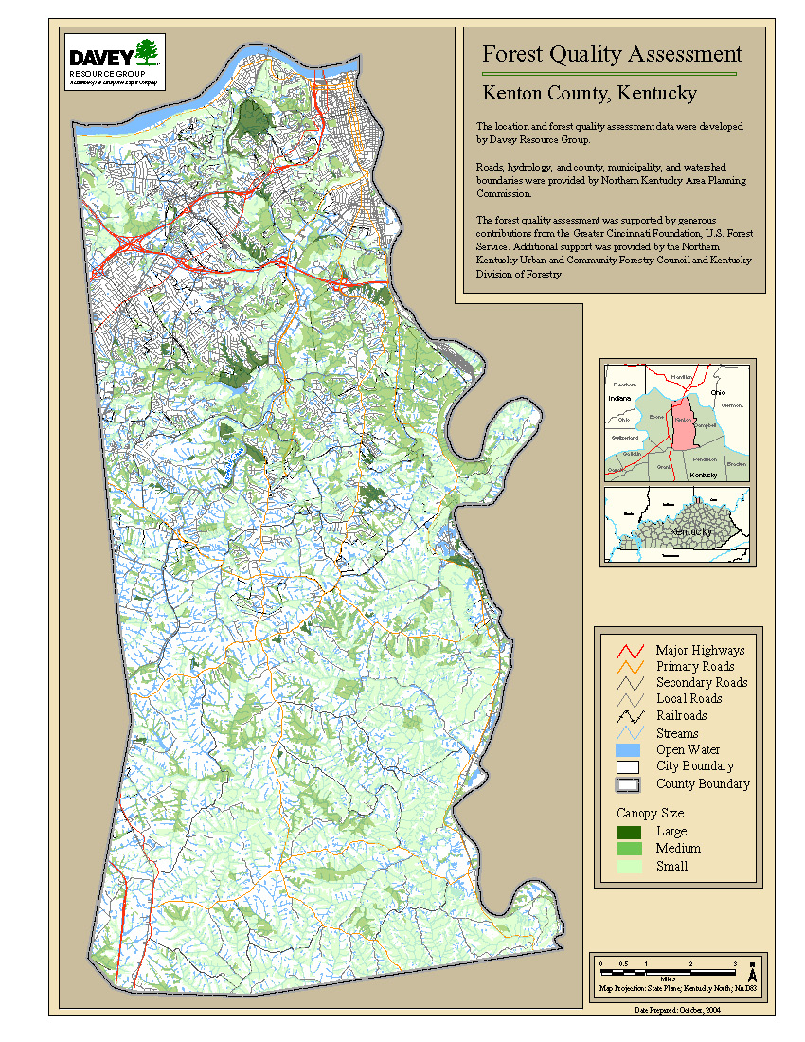
Figure 1. Forest Quality Assessment Map of Campbell County, Kentucky

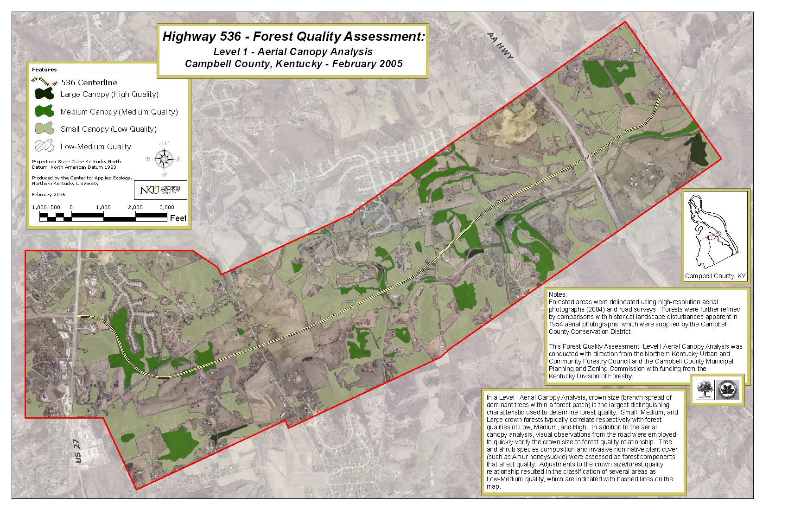
Figure 2. Forest Impact Study of Kentucky State Route 536 Improvement Plan

It is anticipated by the Council and their project partners that this critical forest information, presented in a landscape scale, will be utilized more and more to create the basis and framework for decision-making in local and regional development projects, and to identify critical areas in the region where the forest cover should be protected and enhanced to maximize the benefits of forest resources for humans.

All maps and full reports of this project are available on the Northern Kentucky Urban and Community Forestry Council’s website: www.nkyurbanforestry.org

Framing the Issues with Green Infrastructure

Cheryl Kollin, Vice President, Urban Ecosystem Center

American Forests, Washington DC

Abstract: Based on the upcoming publication, Planning the Urban Forest: Ecology, Economy and Community Development by the American Planning Association, this paper summarizes strategies and examples of how to frame planning and development issues in the context of using green infrastructure to meet environmental quality goals. The strategies can help planners and local leaders translate goals into policies and implementation methods.

The American Planning Association, in close collaboration with American Forests and the International Society of Arboriculture it’s upcoming Planning the Urban Forest: Ecology, Economy and Community Development, offers a best practices manual about how urban and community forestry can best be integrated into long-range and current municipal planning activities in the U.S. This paper offers strategies and examples of how innovative communities have reframed their environmental problems in the context of using green infrastructure as a solution to meet their environmental, regulatory, and community enhancement goals.

The Strategies

- From urban sprawl to Smart Growth
- From traditional development to conservation development
- From natural disaster clean-up to building resiliency into the environment
- From engineered infrastructure to non-engineered best management practices

From Urban Sprawl to Smart Growth
City of Detroit Greenways

Between 1950-1990 the city of Detroit lost one half of its tree canopy to Dutch Elm Disease. Exacerbating this dwindling urban forest, the city has recently lost 16 million trees to Emerald ash borer. From a real estate perspective, Detroit has 66,000 vacant lots totaling 4,600 acres of land as development has shifted from the city to the suburbs over the last several decades. However, as developable land dwindles and land costs rise infill housing and redevelopment will become more prevalent. Taking a Smart Growth approach to redevelopment, the city could incorporate greenways with enhanced green infrastructure into redevelopment of these vacant lots.

The city’s planning department and the Greening of Detroit, a non-profit organization have envisioned what this would look like, starting with the Dequindre Cut Greenway, an old railroad right of way. Their redesign of this abandoned land demonstrates the ecosystem benefits of one greenway. The greenway currently is 3,251 acres with a 150 ft. vegetation buffer with a 19% tree canopy. The greenway system’s tree canopy currently provides $7.6 million in stormwater management value. If tree canopy were increased to 25% of the landcover, the community would save an additional $2 million in stormwater management value.

From Traditional Development to Conservation Development
Flower Mound, Texas

Flower Mound, Texas, a 43-square-mile community located 28 miles northwest of Dallas, experienced rapid growth in the 1990s. The town was the nation's tenth fastest growing community during the 1990s, growing by 226.54 percent, from 15,527 to 50,702. This prompted the town manager and other elected officials to take measures to preserve the rural, open space character of their town and its unique landscape features. While the town’s overarching public policy was to preserve its open space, the driving forces were rapid development and the resultant impacts on stormwater and water quality. This case study serves to demonstrate how a community can quantify the environmental benefits derived from conservation development.

The town council adopted a Smart Growth approach of preserving natural open space and forest lands. They created a conservation development provision within the town’s Code of Ordinance and designated two conservation developments in the undeveloped southwest part of town. Conservation development is defined as a residential development project that does not increase net density and clusters dwelling units on smaller lots than are currently zoned in order to protect and preserve open space.

Conservation Development Benefits

- Preserves natural functions of floodplains and riparian corridors
- Prevents habitat fragmentation
- Protects significant contiguous forest stands
- Preserves rural character of landscape
- Developers sell lots at a premium
- Infrastructure costs are less
- Conservation developments given review preference
- Residents enjoy living near open spaces and greater home value

Sanctuary, an 89-lot conservation development on 100 acres located in the south-central part of town, was used to demonstrate the ecosystem benefits of conventional versus conservation development land planning. The lots are approximately ½ acre in size, in an area that conventionally would be one acre.

Two land development options were modeled using American Forests’ urban ecosystem analysis, an innovative way to examine the role that land cover provides in improving water and air quality. The first compared lot size (1/2 acre versus one acre) to the ecosystem benefits of the preserved open space and tree cover when the number of lots remains the same. A second series of analyses examined the built lot, to address how the proportion of tree canopy, open space, and impervious surface affects the ecosystem benefits to the site as a whole.

The residential lots on ½ acre lots represented 47% of the Sanctuary site compared to one acre lots that comprised 95% of the site. Because less tree canopy and open space were preserved under the conventional development scenario, this site would require an additional 27,000 cubic feet in stormwater management valued at $54,000 when compared to the conservation development site.

Water pollution is a direct result of and can be calculated from stormwater runoff. While the water quality of both developed sites diminished, the conventional site design added more contaminants than the conservation development scenario

Built Lot Modeling

While lot size is an important consideration when conserving open space, the amount of stormwater runoff is also greatly affected by the land cover percentages once the lot is built. For example, an urban ecosystem analysis compared Sanctuary’s land cover on Lot A with more tree canopy and open space to Lot B with more impervious surface. The urban ecosystem analysis findings show that compared to developed Lot A, an additional 1,286 cubic feet of stormwater runoff occurs in developed Lot B, at a cost of $2,573. Reducing the building footprint, sidewalk, and streets (impervious surfaces) and enhancing the tree canopy and other vegetation (green infrastructure) reduce the cost of managing stormwater runoff and protecting water quality.

The Town of Flower Mound’s Environmental Resources Division will continue to use the urban ecosystem analysis to aid in conducting environmental site assessments and development review.

From Natural Disaster Clean-up to Building Resiliency into the Environment
Palm Beach, Florida

Palm Beach County is part of the Everglades ecosystem, which stretches from the numerous lakes in Central Florida south to the Florida Keys. This unique U.S. Ecoregion is characterized by its flooded grasslands and rich wildlife that resides within the county’s one-half million acre natural areas. These natural areas are critical for protecting the county’s drinking water as well as providing thriving agriculture and tourism industries. The county is also subject to annual tropical storms and hurricanes, destroying property and the very green infrastructure that protects its shorelines.

Prompted by a significant tree canopy loss from Hurricanes Francis and Jeanne that battered the region in September 2004, Palm Beach County received a grant from the Federal Emergency Management Agency (FEMA) to conduct an Urban Ecosystem Analysis. This case study presents how Palm Beach County leaders will use this study’s findings and tools as a baseline for urban forestry restoration and, more broadly, to connect future land planning decisions to green infrastructure.

Landcover Changes between 2004 and 2006:
- 6% increase urban
- 17% decrease tree canopy
- 9% increase open space
Impacts:
- Lost $157 million stormwater retention capacity
- Lost $12 million in air pollution removal/yr.
- Lost 1.8 million lbs. of carbon storage
- 8 measured water pollutants increased 2-4%

The county can build resiliency into their planning process using the land cover data and ecosystem analysis findings in the following ways:
- Provides tangible evidence of suitable habitat for trees, including no irrigation or lawn around trees
- Provides public education extolling the benefits of trees replacing public fear of trees in disaster prone areas
- Provides tangible evidence of the best species for future planting: native vs non-native
- Ties ecosystem benefits of county’s natural areas into regulatory mandates:
  - Wetlands and conservation areas
  - Air quality
  - Water quality
  - Estuarine systems
  - Native vegetation
  - Wildlife habitat

This digital GIS land cover map will help planners prioritize their reforestation efforts and tree give-away programs, and aid in determining best species selection for future planting. For example, Hurricane Jeanne affected the more northern part of the county, since it made landfall in Martin County to the north. Many sand pine trees toppled outright during the storm. Slash pine resisted the initial path of the damage, but the county now sees massive die-off from subsequent bark beetle infestations attacking the stressed trees.

In contrast, Hurricane Wilma went straight through Palm Beach County. This time the densely populated southern part of the county was most affected. Unfortunately, a lot of trees in the south are exotic to the region and as such, were ill-adapted to hurricane conditions. Local experts recommend planting live oak as a replacement; even though it is a commonly planted species, it is also one of the best natives for withstanding hurricanes.

The county can also use the data in public education programs to extol the tangible benefits of urban forests. Tangible data are especially important in disaster-prone areas. Citizens are often fearful of replanting trees, believing them to be more of a hazard than of benefit in hurricane zones. When benefit data are combined with information about the best species and planting locations for hurricane-prone areas, citizens are more apt to support reforestation efforts in their communities.

From Engineered Infrastructure to Non-engineered Best Management Practices
McDowell Creek Watershed, North Carolina

Mountain Island Lake Watershed (MIL), a 70-square-mile area within Mecklenburg County, North Carolina, provides 80 percent of the drinking water for the 700,000 people who live there. This rapid development has severely threatened the community’s water quality. The water entering Mountain Island Lake from McDowell Creek, one of its larger subwatersheds, is already unhealthy for swimming. McDowell Creek Watershed’s 30 square miles has thousands of existing homes, and many more are planned.

An urban ecosystem analysis of Mountain Island Lake landcover examining satellite imagery between 1984 and 2003 revealed these ecosystem changes:
- 14% increase in flooding potential as measured by the increase in flow depth
- 17.3 million cu ft. additional stormwater management required valued at a cost of $34.7 million value

Another analysis of McDowell Creek Watershed taken in 2001 revealed the landcover to be:
Tree Canopy 51%
Open Space 24%
Impervious 12%
Bare Soil/Ag 11%
Water 2%

This data provided a baseline of the watershed’s ecosystem services:
- 53 million cubic feet of stormwater
- Stormwater retention valued at $105 million

For the first time, with this data the Charlotte-Mecklenburg Stormwater Services staff is using the GIS-based data and urban ecosystem analysis in addition to traditionally engineered stormwater techniques. The staff uses CITYgreen software to model increases in tree canopy and the resulting water quality improvement to determine the extent of planting needed to achieve its water quality standards. Staff uses the analysis approach with CITYgreen to:

- Identify, prioritize, and measure tree-save areas for stream bank restoration and stabilization. The data reveals breeches in riparian buffers pinpointing where reforestation is needed
- Measure the contributions that reforestation in a particular zone will have on water quality and model increases in tree canopy and water quality improvement
- Augment engineered techniques with land cover to achieve it water quality standards
- Monitor how effective the Watershed Management Plan has been and what adjustments need to be made. The data also augments their zoning review process to aid in decision making.

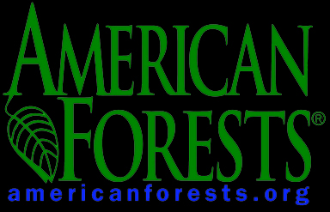

P.O. Box 2000 | Washington, DC 20013 | 202.737.1944

